Created → Jan 22, 2026 | Last update → Jan 22, 2026

Intro to

JavaScript

Point of contact → Tay Za
BIB Institute

01

Introduction.

How JS started
- Released in 1995
- First called Mocha, then LiveScript then changed to JavaScript to follow along the Java hype at the time.
- Lightweight interpreted or just in time (JIT) compiled language
- A multi-paradigm language meaning it has both the properties of functional ( higher order functions like map, filter, reduce ) and object oriented programming languages ( objects, classes, encapsulation, inheritance ).

1. Traditional Compiled (AOT) Languages
- C and C++: The bedrock of high-performance software. Because they compile straight into raw machine code, they are used to build operating systems (Windows, Linux), game engines (Unreal Engine), and flight control software.
- Rust: A modern language designed to be as fast as C++, but with strict safety guardrails built into the compiler to prevent memory crashes and security bugs.

2. Interpreted Languages
- Python (Historically/Standard): When you run a standard Python script, the CPython interpreter reads your code and executes it step-by-step.
- Bash / PowerShell: The scripting languages built into Linux and Windows terminals. When you write a script to back up files or automate a server task, the shell interpreter reads and executes those commands one single line at a time.

2. Other JIT-Compiled (Hybrid) Languages
- Java: Java uses a two-step hybrid approach. It first compiles your code into an intermediate format called Bytecode. Then, when a user runs the app, the Java Virtual Machine (JVM) interprets that bytecode, using a highly sophisticated JIT compiler to turn hot paths into blazing-fast native machine code.
- C# (.NET): Similar to Java, C# compiles into an intermediate language. When the application runs on the .NET runtime, the JIT compiler translates it into native machine instructions tailored exactly to the specific CPU the user has.

02

Actual Coding.

Foundations
Same foundation as every other programming languages with variables, loops, conditions, switches etc.

Variables
JS has 3 ways to declare variables.
- var ( the oldest way, not recommended anymore )
- Let ( a better version of var )
- Const ( constant, cannot reassign )

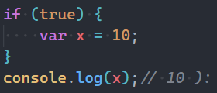
var behavior

Functions
Normal Function syntax
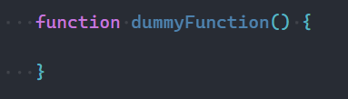
- Can be hoisted

Arrow Function syntax
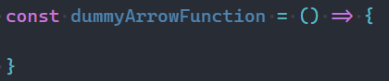
- Can’t be hoisted.
- Used more for jsx functions ( next, vue etc )

Loops
While Loops
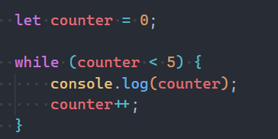

For Loops
- Foreach loops
- Normal for loops
Foreach Loops
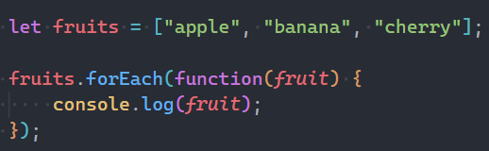
- Only work on arrays and only for going through the arrays.
- No breaks, no control in the loop
- Useful in frontend dev

Conditions
Normal If conditions
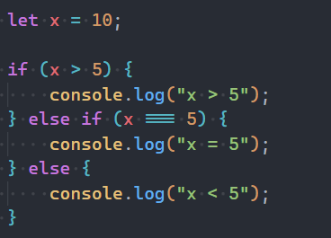
Switches
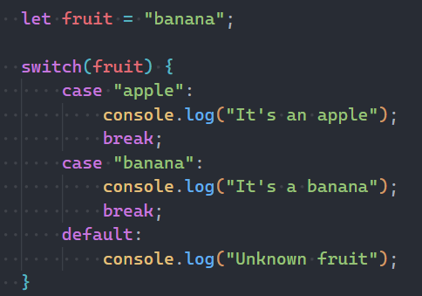
Instead of multiple if-else statements, use switch.

Ternary Operators
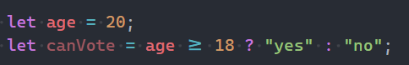
- For simple if-else statements, ternary operator is commonly used for its readability.

DOM Manipulations
https://www.w3schools.com/js/tryit.asp?filename=tryjs_dom_method
https://www.w3schools.com/js/tryit.asp?filename=tryjs_dom_getelementsbytagname2

Folder Name : javascript_demos

01

DOM Manipulation.

What’s DOM
- Short form for Document Object Model ( DOM )
- Everything HTML is turned into an Object Tree

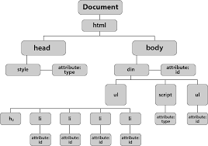

Selecting the DOM
- Query Selector
- Get element by ID
- Get element by Class Name
- Get element by Tag Name
- Get element by name ( used in forms )

Query Selector
- Basically selecting elements with CSS selectors.
- ( .class, #id, div > p, etc )
- Returns a single element ( the first element that matches )
- queryS
- electorAll returns an NodeList ( array ) of elements
By ID
- Selecting elements with its IDs.

By Classname
- Returns all elements with that class as an HTMLCollection.
- Live collection: updates if DOM changes.

By Tag Name
- Returns an HTMLCollection of all elements with that tag.

By Name
- Often used in forms.
- Returns a NodeList of elements with that name attribute.

Manipulating the selected DOM
- Manipulating the styles directly
- Attribute manipulation
- Add or remove classes
- Remove elements
- Text manipulation

Manipulating styles
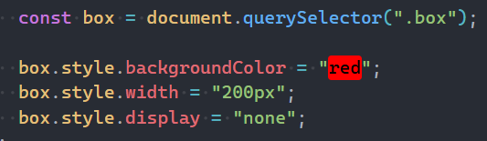
- Can call styles of selected element with element.style.{property}

Attribute Manipulation
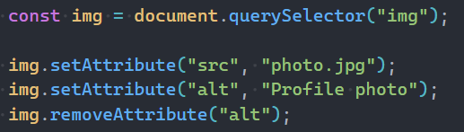
Normal way
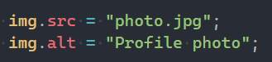
Easier Common way

02

Events.

Handling Events
- Adding Event Listeners
- element.addEventListener(type, listener, useCapture) (The modern, flexible approach)
- Example:
document.getElementById('myButton').addEventListener('click', function(event) {
console.log('Button was clicked!');
});

- Inline Event Handlers (e.g., <button onclick="...">)
- Legacy approach: element.onclick = function() {}
- Removing Event Listeners
- element.removeEventListener(type, listener, useCapture)
- Note: The function reference must be the same one used in addEventListener.
- Example:
function handlerFunction() {
console.log('Fired');
}
let element = document.getElementById('target');
element.addEventListener('click', handlerFunction);
element.removeEventListener('click', handlerFunction);



The Event Object
- The object passed automatically to the handler function, containing details about the event.
- Key Properties
  - event.target: The element that triggered the event (where the event originated).
  - event.currentTarget: The element the event listener is attached to.
  - event.key: The key pressed (for keyboard events).
  - event.type: The type of event (e.g., 'click', 'mouseover').
- Preventing Default Behavior
  - event.preventDefault(): Stops the browser's default action (e.g., preventing a link from navigating or a form from submitting).
  - Example:
document.querySelector('a').addEventListener('click', function(e) {
e.preventDefault(); // Stops the link from going anywhere
alert('Link prevented!');
});



Event Flow and Delegation
- Event Bubbling
  - The default process where an event propagates up the DOM tree from the element where it originated to its ancestors (body, html, document).
- Event Capturing
  - The opposite phase, where the event travels down the DOM tree to the target element. Rarely used, enabled by setting the third argument of addEventListener to true.
- Event Delegation
  - Attaching one single event listener to a parent element to manage events for all its children. This is efficient for lists or dynamically added elements.
  - Example (using bubbling):
document.getElementById('parent-list').addEventListener('click', function(e) {
if (e.target.tagName === 'LI') {
console.log('List item clicked:', e.target.textContent);
}
});



Common Event Types
- Mouse: click, dblclick, mouseover, mouseout, mousedown, mouseup.
- Keyboard: keydown (when key ish pressed), keyup (when key is released).
- Form: submit (on form submission), input (when value of input changes), change (when focus leaves a field whose value was changed), focus, blur.
- Window/Document: load, scroll, resize.

Jquery.

Introduction

- Started in 2006
- 88% of all sites still use Jquery but the usage is slowly declining
- a fast, lightweight JavaScript library that simplifies
  - DOM manipulation
  - Event handling
  - Animations
  - AJAX

Why Jquery?
- Cross-browser compatibility
- Shorter syntax
- Easy animations
- Beginner friendly

Set Up
- CDN link
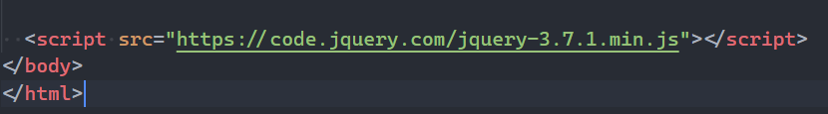
- Download and connect from jQuery

Jquery Events

- $ is used to select DOM contents.
- Document ready event
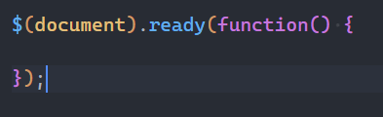
- Click Event
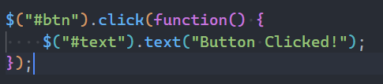
- Double Click Event
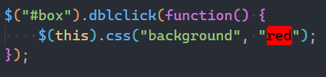
- Hover Event
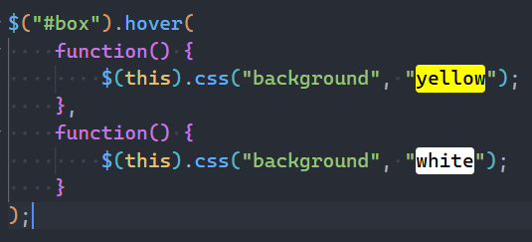
- Form Submit Event
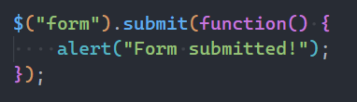

Jquery Animations

- Hide elements
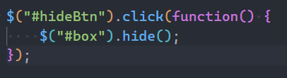
- Show elements
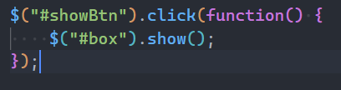
- Toggle
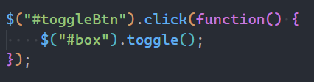
- Use animation speed
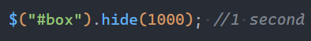
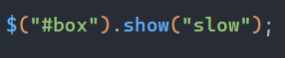
Slow = 600 ms
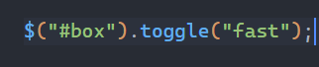
Fast = 200ms
Default = 400ms

Useful Features.

.text
- To change the text content of an element.
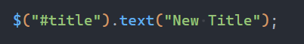

.html
- To change the html content of an element.
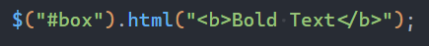

.val
- To get/set the value of an input
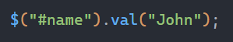
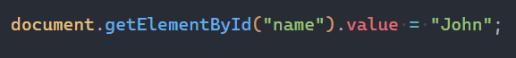

Add / Remove / Toggle Class
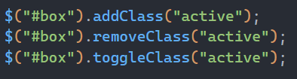
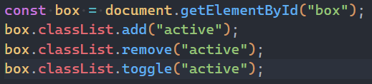

Click Event
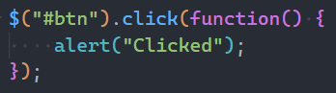
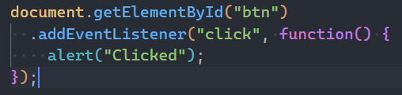

Hover (mouseenter / mouseleave)
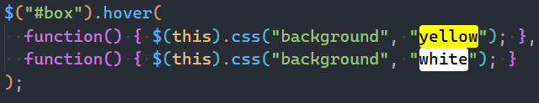
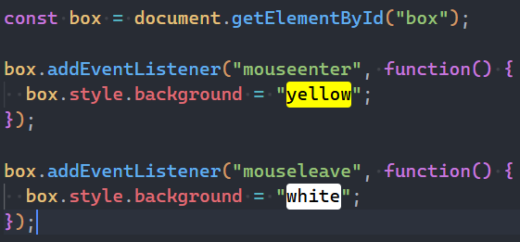

Hide / Show
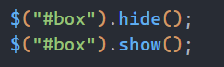
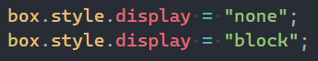

Create & Append Element
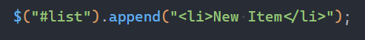
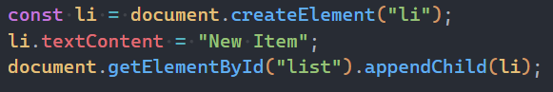

Swiper

What is Swiper
Swiper.js is a modern JavaScript slider / carousel library used for:
- Image sliders
- product galleries
- mobile touch sliders
- hero banners
- card carousels
Supports:
- touch gestures
- responsive layouts
- modular features
- hardware accelerated animations

Basic Setup

- Install Swiper
- can install via CDN or npm.
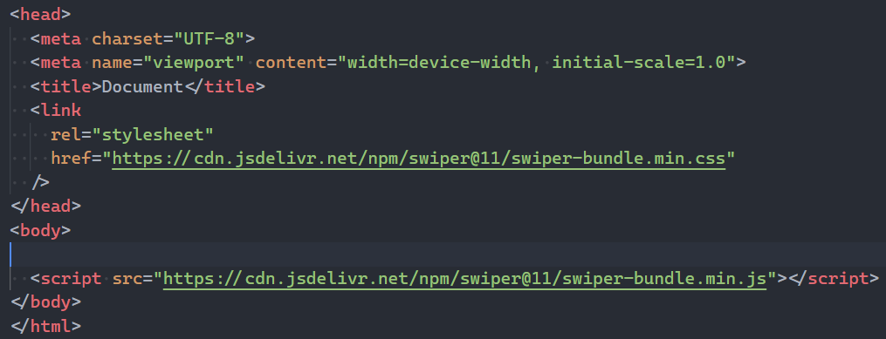

- Basic HTML Structure
  - Swiper requires a specific structure.
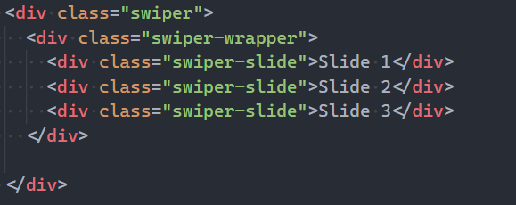
- Swiper : main container
- Swiper-wrapper : holds all slides
- Swiper-slide : each individual slide

- Initialize Swiper
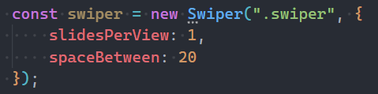

Key Options

- slidesPerView -> how many slides visible ( auto is common )
- spaceBetween -> spacing between slides
- Speed -> animation speed
- Loop -> enable infinite sliding
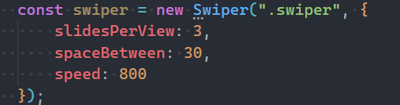

Loop Mode

- Makes the slider cycle infinitely.
- Instead of stopping at the last slide, it jumps back to the beginning smoothly.
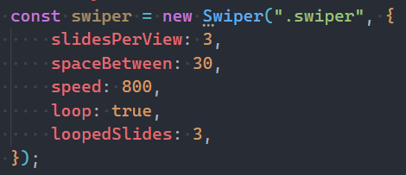
- Put the number of slides ( before looped ) in loopedSlides to mitigate any risks of bugs

Pagination

- provides visual navigation indicators.
- Usually dots under the slider.
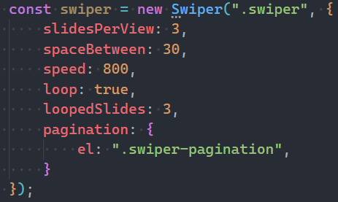
- Clickable pagination
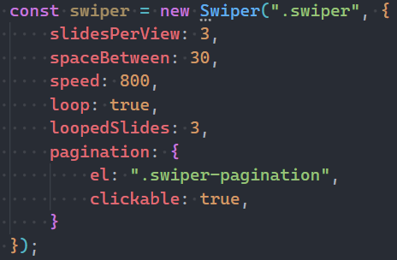
- Pagination Types
  - Bullets -> default dots
  - Fraction -> 1 / 5 style
  - Progressbar -> loading bar style

Thumbs (Thumbnail Gallery)

- Thumbs allow one slider to control another slider.
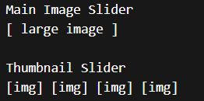
- Clicking a thumbnail changes the main slide.
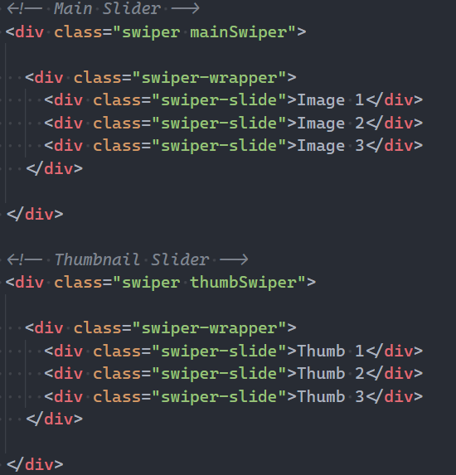
- First initialize the thumb slider.
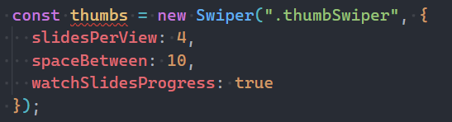
- connect it to the main slider.


